**Guidance Class Lesson for the week of May 18-22**

**Let’s learn about handling Worries: Lesson 6**



Hello 2nd grade students! I miss you all so much!

This week we are learning about how to handle worries or anxiety! We all have worries sometimes, and we have to learn how to handle them. There are some great strategies to help us to calm down and get grounded. Things like taking a break, deep breathing, thinking positively, and staying busy can help us handle stress and worry. It’s good to know these strategies when we feel worried inside.

1.Watch the video: “Managing Worry and Anxiety for Kids”



<https://www.youtube.com/watch?v=l7g8Atv27Q8>

2.Read the book, “Don’t Feed the Worry Bug” By Andi Green.

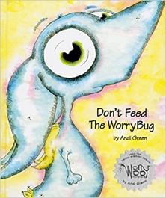

<https://www.youtube.com/watch?v=JM27Zj04EOM>

3. Here are some activities to print about handling worries: Worry strategies , Calm a Llama, Llama coloring